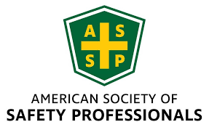

**NEIL ASSP Chapter Monthly Board Meeting**

**Submitted By: Jay Braffett, CSP**

**November 15th 2024**

Attendance: Claire Obuchowski, Toma Balaci, Sheri Lesak, Jay Braffett, Bob Wasick, Tim Janis

**Meeting Call to Order**

* Jay Braffett 1:13pm

**Board Member Reports**

1. Past Minutes - Claire Obuchowski – motion to approve October Minutes. Accepted.
2. Secretary – Claire Obuchowski
   1. 24 attendees at November meeting. 6 walk-ins.
3. Treasurer – Toma Balaci
   1. Report attached at the end. PO Box paid in November. Toma to purchase a presenter microphone, new projector, speaker and bag for money/checks.
4. Newsletter – Tori Bankson (not present)
5. Membership – Mike Themanson (not present)
6. Chicagoland Safety and Health Conference – Sheri Lesak
   1. Amy Beug will be taking over for Sheri. In 2025, they will co-chair the conference to familiarize Amy. Amy has been added to the website officer page.
   2. 408 attendees this year. Made the most profit ever, with ~$17k going to each participant group.
7. Awards and Honors – Bob Wasick
   1. Nothing to report.
8. NIU Student Section Advisor – Dr William Mills (not present)
   1. Dr. Ted Hogan to replace Dr Mills as NIU Student Section Advisor. Dr Hogan attended the presentation at this Chapter Meeting. Website updated with Dr. Hogan name and photo.
9. NIU Student Section – Matt Hoffman (not present)
   1. Matt is no longer interested in this position and has been removed from the chair position and removed from the website.
10. Webmaster – Justin Cathey (not present)/ Claire Obuchowski
    1. Justin is no longer interested – looking for a replacement. Tim Janis to ask Tanner Panozzo if he is interested. Claire would train.
    2. Claire posted photos from Harper Experience Day, Northern IL Food Bank volunteer event, and from this chapter meeting on the website. Minutes from October meeting posted, as well as Mark Lies’ presentation.
11. President Elect & Sponsorship Chair – Jaime Feinberg (not present)
12. Past President – Tim Janis
    1. Will contact Tanner P for website chair position and possibly an ASSP tablecloth for presentation table.

**Past Business**

* November 12th 2024
  + Volunteer Event at Northern IL Food Bank in Geneva, IL
  + 9,902 lbs of food packed
  + 8,251 meals provided
* ASSP NIU Chapter
  + Dr. Hogan agreed to serve as new NIU ASSP Student Section Advisor

**New Business**

* 2024 – 2025 Monthly Meeting Upcoming Schedule
* December 6th
  + Monthly Board Meeting
  + Virtual Teams Meeting 9am to 10am – Jay to ensure Dr Hogan is added to the invite.
* January 17th 2025
  + Workers Compensation understanding for Safety Professionals – Adam Cox
    - Confirmed – Sheri to reach out for bio and photo to post.
* February 21st 2025
  + Diversity, Equity, and Inclusion as it applies to the Safety Professional – Dr. Geneace Williams
    - Confirmed – Tim to reach out for bio and photo to post.
* March 21st 2025
  + Confined Space Rescue – Sean McNichols
    - Confirmed – Toma to reach out for bio and photo to post.
* April 25th 2025
  + EMS for the Safety Professional– Mick Fleming
    - Confirmed
* May 23rd 2025
  + LOTO Applicable to the Safety Professional – Aaron Gelb
    - Confirmed
  + Chapter Newsletter
    - No updates
  + LinkedIn NEIL ASSP Chapter
    - Claire was made an owner of the LinkedIn page by Rick Pokorny (original owner). Bob Wasick, Tori Bankson, and Amy Timmerman are managers of the page. Claire posted photos and info from recent events on the page and added members.
  + Speaker photo in bio of each monthly meeting – Send to Claire to add to website as soon as possible.
  + Board meeting prior to monthly meeting
    - 10:30-11:30am
    - Bob W. to ask Maggiano’s – we can come in early to Maggiano’s – confirmed.
  + Photo section on website with last months meeting photos – complete
  + Training modules on ASSP website
    - Must add to cart and checkout
  + New ASSP website now active
  + Region V homepage visit
    - Upcoming events, webinars, broad overview of region V updates
  + More Member Involvement
    - Establish CEU credits for attending meetings o We need to submit the info early and get outlines of presentations to submit.
      * Tim Janis volunteered to lead
      * ASSP needs information at least 30 days in advance
* Contact general members and board members who are not attending meetings on a consistent basis and determine how to increase their attendance/participation
  + Increase Chapter interaction and participation with NIU Student Chapter
* Host an Information Session
* Take a tour of the NIU Safety Department
* Meet new department chair
* Determine Scholarship for students

**Meeting Adjourned**

* Jay Braffett 2:02pm

Treasurer Report November 2024

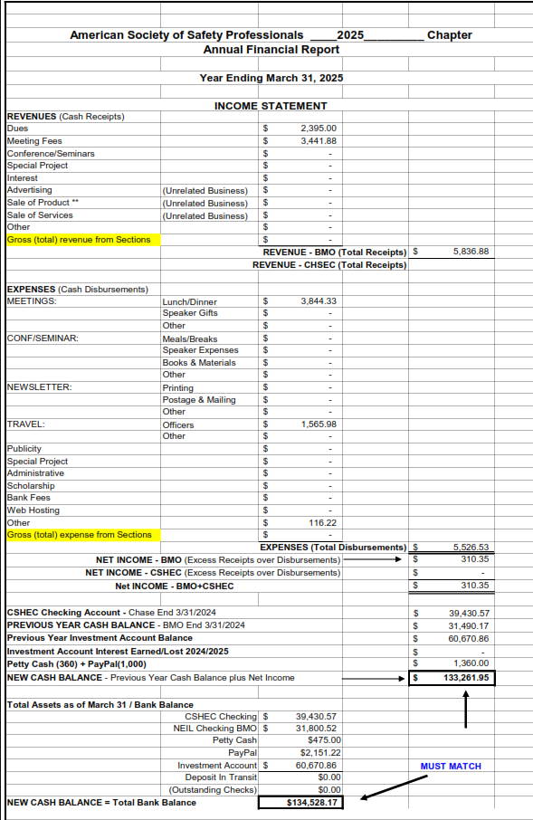

Notes/Transactions since last report:

|  |  |
| --- | --- |
| Date | Description |
| 09/27/24 | September Dues |
| 10/07/24 | ASSP Region V ROC Meeting - Jay Braffett |
| 10/17/24 | ASSP Region V ROC Meeting - Jay Braffett |
| 10/18/24 | Cashed Check - October Meeting - Janelle Holda |
| 10/18/24 | Chapter Award Reimbursement - Bob Wasick |
| 10/18/24 | Chapter Meeting - Maggianos |
| 10/18/24 | Travel Reimbursement ROC - Tim Janis |
| 10/29/24 | CSHEC Account Reimbursement - Claire Badge Holders |
| 10/31/24 | October Dues |