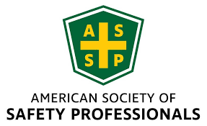

NEIL ASSP Chapter Monthly Board Meeting Agenda
February 20th 2026
Submitted By: Jay Braffett, CSP
Attendance: Jay Braffett, Tanner Panozzo, Sheri Lesak, Gerald Greer, Ted Hogan, Jailene Benitez, Claire Obuchowski, Amy Beug
Meeting Call to Order Jay Braffett 10:10am
Board Member Reports
- Secretary – Claire Obuchowski
  - January meeting minutes posted on website.
  - Reminder to board to register on the website even though it is free so you can be included in the count.
- Treasurer – Toma Balaci (not present)
  - US Environmental deposited payment for NIU Equipment calibration. This was split between NEIL and Three Rivers. ($562.32 NEIL Portion)
  - Kamran Reimbursed for retirement gift
  - Working with Tanner to create different payment account through Square to replace PayPal.
  - Will likely buy new payment device for Square. Will cost roughly $60
  - Sheri given check to pay for Maggiano’s Feb. chapter meeting.
- President Elect – Sheri Lesak
  - Has the payment device from Toma
- Past President – Tim Janis
  - Will be reaching out to board members up for election to see if they are still interested in continuing or if we need new board members.
  - Wants to pass on his attendance funded by chapter to the PDC to Sheri but she is unsure if she can make the time due to personal commitments.
- Webmaster – Tanner Panozzo
  - Took down a resume that was up on the website for awhile as they found a job.
  - Working with Toma and Home Office to get PayPal issue sorted out. PayPal has not gotten back to them, so they may switch to Square instead.
- Newsletter – Tori Bankson (not present)
- Membership and Sponsorship – Gerald Greer
  - By next meeting, would like to send out a survey to membership to improve next year.
  - Need to plan site visit for NIU students for near future - April 1st or March 20th?
- Chicagoland Safety and Health Conference – Amy Beug
  - AIHA check was cashed.
- Awards and Honors – Bob Wasick (not present)
- NIU Student Section Advisor – Dr Ted Hogan
  - In April, students will be doing posters at the Three Rivers Meeting and then the NEIL Chapter.
- NIU Student Coordinator – Kamran Malik (not present - Jailene Benitez as representative),
  - Three Rivers is paying for graduation stoles for this year and they want NEIL to pay next year.
  - Need letters of endorsement by April 1st (Jay to take care of by next week).
  - Recent student meeting went very well – well attended, food provided, shared information on scholarships and encouraged students to apply.
Past Business
New Business

- Follow Up on last meeting Open Action Items:
  - Renew NEIL ASSP PO Box
Owner: Treasurer
  - Need to follow up with Toma to make sure this has been done.

  - Finalize 2025 Chapter Donation
Decision needed: Confirm recipient (recommended: NIU Student Food Pantry)
Voted to confirm $1000 donation from NEIL. Jay will contact JD Horst about donation possibility.

  - Confirm Scholarship Details and Publish on Website
Email sent to all Board Members with Template
  - Ownership to complete - This has been completed. There have been some applications submitted.

  - Develop and Distribute Sponsorship Solicitation
Target audience: CHSEC vendor list
Owner: Membership & Sponsorship Chair
  - Gerald to work on this.

  - Publish Resume/Scholarship Workshop Photos for website and newsletter
Owner: Webmaster / Newsletter
Tanner completed this.

  - Resolve NEIL ASSP Website Officer Page Issues
  - Correct missing board members and titles
  - Address missing officer photos
  - Follow up with ASSP on chapter control of officer page updates
Completed – Email Sent –
  - Idea: send you photo the ASSP Chapter services and ask them to update the photo.
  - Jay will reach out to get Toma’s, Bob’s, and Tori’s pictures to try to get them on the website.

- Coordinate with Three Rivers ASSP on Equipment Calibration Collaboration Status
- Promote WISE Event to NIU ASSP Student Section
Owner: NIU Student Coordinator
- This was talked about at the student meeting.

- WISE – Women in Safety Event
  - Website/LinkedIn Promotion
  - Next one will be in April, but no date has been set.

2025– 2026 Monthly Meeting Schedule

- On-Site Injury Prevention and Physical Therapy – Tanner Panozzo
  - January 16th - Completed

- Diversity, Equity, and Inclusion (DEI) in the Workplace as it applies to the Safety Professional – Dr. Geneace Williams
  - February 20th - DEI Presentation

- LOTO Program Management as it Applies to the Safety Professional – Scott Stoner
  - March 20th - Confirmed

- Northern IL University ASSP Student Section Safety Project Presentations – NIU Safety Department Students
  - April 17th - Confirmed

- ANSI Z10 Standard – Amy Timmerman
  - May 15th - Confirmed

Meeting Adjourned Jay Braffett 11:05am
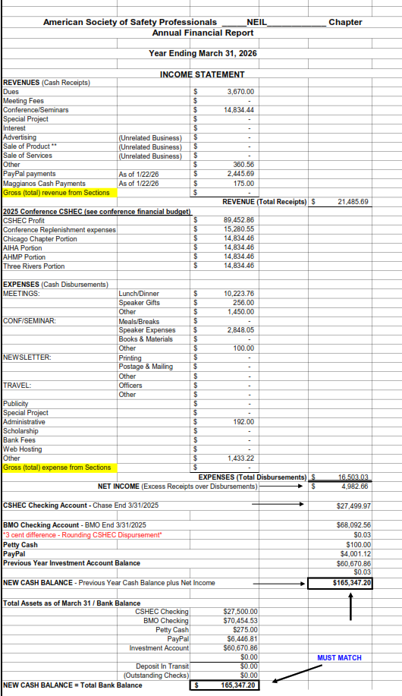

February 2026 Board Discussion Focus Areas

Financial Oversight & Budget Approval (Annual February Requirement)
- Review and approve 2026 Chapter Budget.
- Confirm transfer of PayPal funds (~$6,000) into BMO account.
- Status update on AIHA conference check cashing.
- Review investment account balance and potential ASSP consultation.

Open Action Item Status Updates
- Finalize 2025 Chapter Donation to NIU Student Food Pantry (via NIU Foundation).
- Scholarship details/logo update for website (Kamran update).
- Sponsorship solicitation (Pending Gerald presence).
- Website dashboard access issue – ASSP ticket status.
- Officer page photo updates follow-up with ASSP Chapter Services.
- Equipment calibration collaboration status with Three Rivers ASSP.

Chicagoland Safety & Health Conference (CSHEC) Planning
- Volunteer recruitment for conference committee.
- Keynote speaker discussion – budget allocation consideration: Ted Hogan put a speaker idea out there to the group.
- Attendance growth strategy for 2026.

NIU Student Section Updates
- Calibration invoice payment confirmation.
- March 17th NIU speaking engagement update (Amy).
- Graduation stoles cost-sharing confirmation with Three Rivers.

WISE (Women in Safety Excellence)
- January event recap.
- Future engagement and promotion strategy.

