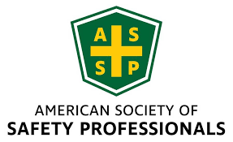
NEIL ASSP Chapter Monthly Board Meeting Agenda
October 16th, 2026
Attendance: Amy Beug, Ted Hogan, Claire Obuchowski, Grace Tilley, Sheri Lesak, Jay Braffett, Toma Balaci, Tanner Panozzo, Kamran Malik
Meeting Call to Order: Jay Braffett 10:03am
Board Member Reports
President – Jay Braffett
- Will ask JD Horst about putting meeting info into the ASSP Journal (PSJ) or somewhere online
- Will research the membership and sponsorship position and get a description (see if it is in our ByLaws)
- Will put together an agenda for career/resume night and coordinate with JD Horst for ordering and payment of food for the event
Secretary – Claire Obuchowski
- May & September meeting minutes added to the website
- CEUs – Send attendance list to Sean Osbourne after the meeting
Treasurer – Toma Balaci
- Investment account transferred over – Mike Thill (sent charter and meeting notes proving that we voted/approved)
- Updated the financial report for month and YTD (reimbursed 3 Rivers for social event)
- Another donation needs to be done before the end of this fiscal year, if we plan on it
  - Donate $1000 to the food bank
  - Donate $1000 to the NIU food pantry
- Chapter emails are undeliverable to Toma for some reason – emails need to be worded a certain way to avoid spam filters
President-Elect – Sheri Lesak
- Nothing to report, will stay on as advisory
- Will send Claire the instructions for CEUs
- Can call HQ for gift cards – keep a list of who receives them
- Needs to confirm December food bank event date (has to wait until November)
- Need November speaker bio and photo
Past President – Tim Janis (not present)
Webmaster – Tanner Panozzo
- Need November speaker bio and photo
- Need to update titles and photos on the NEIL page
- Everyone needs to update photo on their NEIL profile and send it to Tanner too.
Newsletter / Communications – Grace Tilley
- Three Rivers puts their meetings in the ASSP Journal online & physical magazine – is this something we can do?
- Post on the LinkedIn as well – Tanner will make Grace a page manager
Membership and Sponsorship – OPEN
- Will announce that the membership position is still open & put it on the website and LinkedIn
- Gerald will still do a presentation on the results of the chapter survey
Chicagoland Safety and Health Conference – Amy Beug
- Very successful conference
- Email went out with dates for 2027 conference
- 3 entities with outstanding balances (will talk to Sheri to figure out how to resolve that)
- Celebratory dinner on Oct 29th
- Need NEIL volunteers on the conference committee (at least 2 people).
  - Can post on the website and LinkedIn
Awards and Honors – Bob Wasick (not present – health issues)
NIU Student Section Advisor – Dr. Ted Hogan
- Extending invitation to students of all disciplines for resume night
- Need calibration support (send a list so we can collaborate with Three Rivers)
NIU Student Coordinator – Kamran Malik
- In contact with Jailene – Student Chapter re-registered with SGA and Husky Hub, walked in homecoming parade (Jailene may have photos from that to share)
Past Business / September Action Items
• Treasurer: status of $1,500 networking-event contribution and financial report for minutes.
• ASSP Platinum recognition: Jay follow-up with Chapter Services regarding T-shirts
- Claire ordered shirt & it is currently shipping
• Website and communications: Tanner to publish remaining confirmed meetings; coordinate speaker photos, bios and descriptions; Grace to update on newsletters and LinkedIn.
• Conference follow-up: recruiting NEIL members as moderators and conference board volunteers; Jay to discuss joint three-chapter tablecloth with Christine and JD.
• NIU Student Section: Kamran to share student meeting updates and scheduling considerations.
• Jay to follow up with JD / Three Rivers about attending the November chapter meeting.
New Business
Special Election – President-Elect and Secretary
• Conduct October 16 special election in accordance with chapter bylaws and announced nomination/voting process.
• Slated candidates: Claire Obuchowski, CSP – President-Elect; Michael Saujani – Secretary.
• Confirm election results, effective officer transitions, and communication to members.
• Discuss Sheri Lesak’s transition, continued board involvement and October CEU handoff.
• Review leadership succession and staggered Secretary/Treasurer election cycle.
Membership Survey
• Gerald’s PowerPoint presentation of survey results, if available; discuss key findings and next steps.
ASSP Region V Fall ROC – September 23–25
• Brief ROC recap (5 minutes maximum): key chapter takeaways and actions.
• COMT: review progress at board meetings, share reporting responsibilities, and keep updates current; NEIL recognized for 12 Platinum-level years.
• Leadership: build succession plans and recruit volunteers for defined, manageable chapter roles.
• Communications: verify photo permissions and licenses; include image credits on chapter website uploads.
• Conference planning: share best practices for speaker selection, CEUs, volunteers, sponsorships and post-event reviews.
2026–2027 Program and Chapter Updates
• October 16 speaker: John Newquist – Beyond Worker Error: How Great Incident Investigators Find System Failures.
• NIU Student Section Career Guidance & Resume Workshop – confirmed for Thursday, October 22, 2026, 3:30–5:00 p.m., Still Gym 211; networking with safety professionals, résumé guidance, and refreshments.
• November 13 Machine Safety program; December Northern Illinois Food Bank volunteer event.
• Confirm February presentation title with Dr. Geneace Williams and March SIF Prevention speaker.
• Review meeting promotion, registration readiness, CEU submissions and speaker materials.

All board members voted to approve Toma Balaci to access and maintain the Northeastern Illinois Chapter of ASSP LPL Financial Investment Account. See Corporate Resolution Form for details.

2026–2027 Monthly Meeting Schedule
• September 16 – Chicagoland Safety, Health and Environmental Conference – Completed
• October 16 – Beyond Worker Error: How Great Incident Investigators Find System Failures – John Newquist – Confirmed
• October 22 – NIU ASSP Career Guidance & Resume Workshop – 3:30–5:00 p.m., Still Gym 211 – Confirmed
• November 13 – Machine Safety – Gerardo Lara Lenttini, M.S., CSP, CCPSC – Confirmed
• December 4 (first priority) or December 11 – Volunteer at Northern Illinois Food Bank – Confirmed (date selection pending)
• January 15 – AI for the Safety Professional – JD Horst – Confirmed
• February 19 – DEI in the Workplace Ethics Training as it Applies to the Safety Professional – Dr. Geneace Williams – Confirmed (verify title)
• March 19 – SIF Prevention: Moving Beyond Compliance – Confirmed (speaker to verify)
• April 16 – NIU ASSP Student Section Safety Project Presentations – NIU Safety Department Students – Confirmed
• May 21 – OSHA Legal Standpoint Update – Mark Lies – Confirmed
Meeting Adjourned 11:12am
Platinum Leader T-shirt sizes:
Kamran: L
Tanner: L
Grace: L
Toma: XL
Sheri: 3X
Tim: 3X
Jay: XL
Hogan: L
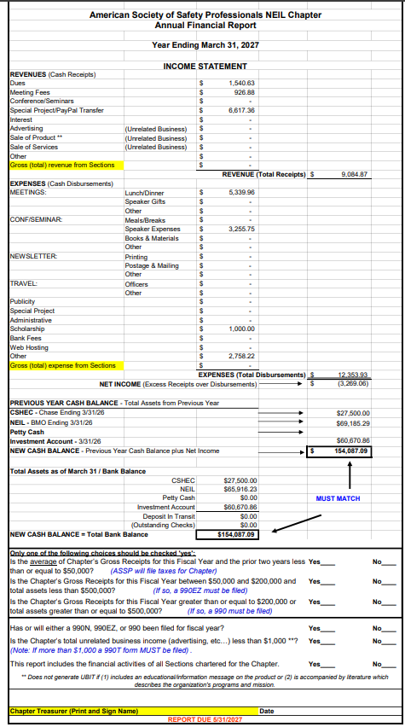
Bob: XL
Amy: L (women’s)

Treasurer Report:

